“OOPs in JAVA”
- OOPs kya hota hai?
OOPs (Object Orineted Programming System) ek programming approach hai jisme program objects ke around design hota hai, na ki sirf functions ke.
Java purely object-orineted nahi hai (kyuki primitive data types hain), but mostly OOP follow karta hai.

- Class
Class ek blueprint/template hoti hai jisse objects bante hain.
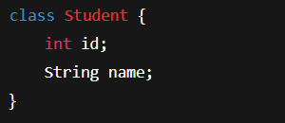
- Object
Object class ka real-world instance hota hai.
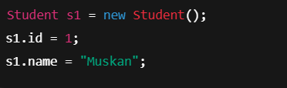
- 4 Pillars of OOPs
- Encapsulation
Data+Methods ko ek unit me badhana= Encapsulation
Data ko Direct access se bachata hai (data hiding).
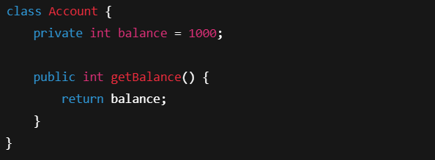
- Private data secure
- Getter/Setter se access
Ek class dusari class ki properties inherit karti hai
extends keyword use hota hai
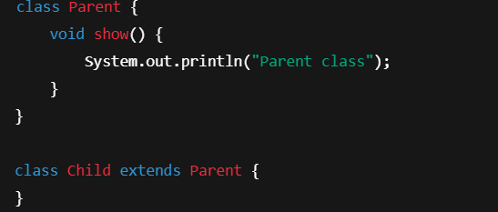
- Code reusability
- IS-A relationship

- Polymorphism
Ek kaam, multiple forms
- Method Overloading (Compile Time)
Same method name, different parameters
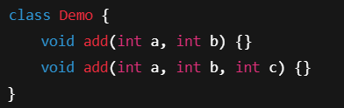

- Method Overriding (Run Time)
Parent method ko child class me change karna
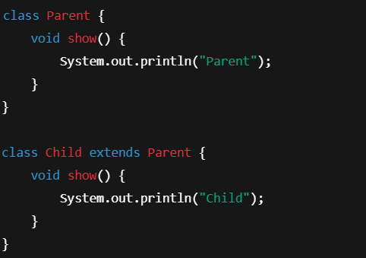

- Abstraction
Implementation details hide karna
Sirf what to do batana, how to do nahi

Abstract Class :

Interface :
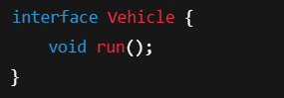
- Interface = 100% abstraction
- Multiple inheritance possible

- Interface vs Abstract Class
Interface | Abstract Class
100% abstraction | Partial abstraction
implements | extends
Multiple inheritance | Single inheritance
No constructor | Constructor allowed

- this keyword
Current object ko refer karta hai

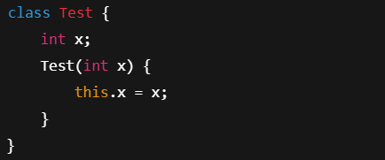

- super keyword
Parent class ke variable/ method ko access karta hai

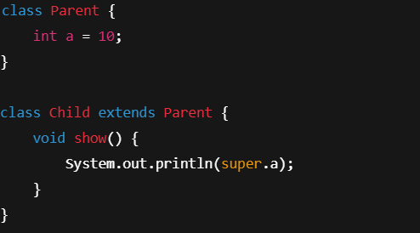

- Constructor
Object banate time automatically call hota hai
Same name as class

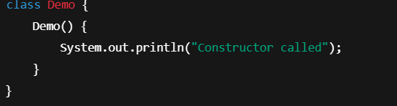

- Benefits of OOPs

- Code reusable
- Easy maintenance
- Secure
- Real-world modeling

